Bermuda Bliss Voyage
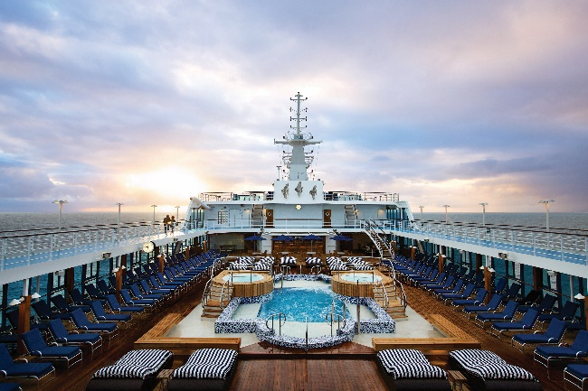
Begin your Couple’s Dream Bermuda Bliss Voyage vacation with a flight into New York City, where you will embark on the Oceania Cruises Insignia ship. The acclaimed Insignia is both sleek and elegantly charming. Her decks are resplendent in the finest teak, and custom stone and tile work. Her lounges, suites, and staterooms boast luxurious, neo-classical furnishings. Insignia offers every luxury you may expect on board one of Oceania's stylish ships. She features four unique, open-seating restaurants; a world-class fitness center and spa, eight lounges and bars; a casino, and 342 lavish suites and staterooms, nearly 70% of which feature private verandas. With just 684 guests to pamper, the 400 professionally trained European staff ensure you will wait for nothing.

Spend your first night and first full day at sea enjoying the luxuries of the Insignia. Wake up to your first destination in St. George’s Bermuda, where you will be in port for more than two days!
St. George is a storybook town, with narrow alleys winding past historic buildings, and charming houses with gardens and whitewashed fences. Founded in 1612, it was Bermuda's first capital. King's Square, the heart of town, has shops and historic buildings. On Wednesday and Saturday at noon, the town crier rings his bell and booms the news of the town. Often, a "criminal" will be brought forward and put in the stocks. Visitors can "imprison" themselves in the stocks and have a photo taken. Pick up a self-guided walking tour map at the tourist office in King's Square. The tour includes the Old State House, built in 1620, making it the oldest building on the islands; the pulpit and cemetery of St. Peter's Church, said to be the oldest Anglican place of worship in the Western Hemisphere; the Town Hall, built in 1782; and Bridge House. Right next to the Tucker House, one of the island's original colonial homes, is Barber's Alley, which commemorates ex-slave Joseph Hayne Rainey. He escaped to Bermuda and worked as a barber before returning to South Carolina after the Civil War to become the first African American elected to the U.S. House of Representatives. Be sure to look for the Unfinished Church, the shell of what was to have been a magnificent cathedral. Other sites include Somers Garden (watch for brilliantly colored chameleons), Featherbed Alley Printery (contains a working 18th-century press), the Featherbed Art Studio and the restored Somers Wharf area (now a shopping and restaurant complex). Also, several beaches are located near St. George's such as Tobacco Bay Beach, known to be one of Bermuda's best beaches for snorkeling, thanks to its crystal clear, shallow waters.
Travel next to Hamilton, Bermuda’s capital city, where you will be in port for two days!
Hamilton is a charming, small city of pastel houses with whitewashed roofs and attractive shops. Block after block of stores and restaurants line Front Street, across from the harbor. Wigged and robed members of the House of Assembly, occasionally seen walking outdoors, meet at the Sessions House on Friday to hold intense yet polite debates. Directly to the south is the Cabinet Building, where the Senate meets on Wednesdays and where the office of the premier is located. The Cabinet meets there every Tuesday. One of the most photographed spots in town is the Birdcage, an elevated, enclosed perch at Front and Queen streets in which a Bermuda-shorts-clad police officer sometimes directs traffic. One block north from the Birdcage on Queen Street is the Perot Post Office, another landmark from the 19th century. Take time to enjoy Queen Elizabeth Park, once the private garden of postmaster William Perot. Other sites to see include Bermuda National Gallery, Bermuda Historical Society Museum, Bermuda Underwater Exploration Institute, Fort Hamilton, the Bermuda Botanical Gardens and Verdmont Museum.
Your vacation concludes with a lovely full day and night at sea disembarking to New York.
This package includes airfare for two from LAX; transportation from the airport to the ship and all the cruise inclusions listed: prepaid gratuities, free internet, free specialty restaurants, free room service 24 hours a day, free shuttles to City Centers, free fitness classes, free still & sparkling Vero water, free soft drinks & specialty coffees, free launderette and more!
Best of Greece Tour Package
Begin your Couple’s Dream Best of Greece Tour vacation with a flight into Athens!
Put the 'oh' in opa and embark on an unforgettable exploration of an ancient land of gods and goddesses, myths and legends. Your springboard to your spellbinding holiday is the vibrant capital of Athens, an effortless mix of ancient treasures and modern verve, which you will have an opportunity to explore after being transferred to your hotel. This evening, join your Travel Director and travel companions for a Welcome Reception, including a light meal and welcome drink. Your first hotel accommodation is provided by the Divani Palace Acropolis. There is no other hotel in Athens to entwine more beautifully the history of ancient Greece with a 5-star rating.
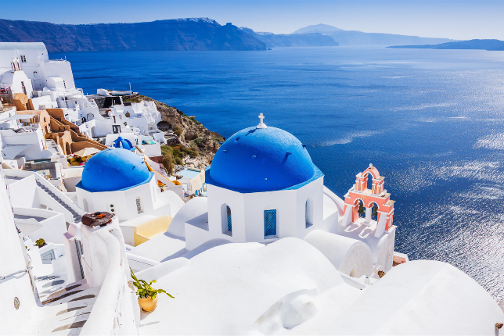
On day two, enjoy a complimentary breakfast before joining your Local Specialist for a guided morning sightseeing tour to the ancient complex that was once the 'Cradle of Western Civilization'. Along your journey into antiquity, you'll have an opportunity to explore the Acropolis with its treasures and admire the Parthenon, dedicated to the goddess Athena, the Royal Palace, Temple of Zeus and the Agora, once the haunt of Socrates and Plato. Dive into culture and see remarkable displays of an ancient world during an included visit to the Acropolis Museum and see Hadrian's Arch and the stadium where the first Modern Olympics took place in 1896. The rest of the day is yours to enjoy on your own. Stroll through the Plaka, people-watch in Syntagma Square or go in search of the city's tastiest souvlaki the choice is yours.
On day three, enjoy a complimentary breakfast before departing Athens to cross the mighty Corinth Canal to the wild Peloponnesian Peninsula. Arriving in Corinth, you will join a Local Specialist to explore an ancient city that several empires fought over throughout the centuries. You will continue to Mycenae, a mighty kingdom of Ancient Greece, where you'll see the Beehive Tombs, (the Treasury of Atreus), the Lion Gate and the remains of Agamemnon's Royal Palace, in the company of a Local Specialist. Later, you'll travel to Epidaurus to visit the ancient theatre and view the Sanctuary of Asclepius, the God of Medicine, whose snake-entwined staff remains the symbol of medicine to this day. Your next hotel accommodation, Amalia Olympia, will host you for dinner that evening. Located in the entrance of Ancient Olympia, Amalia Olympia Hotel is surrounded by Mediterranean gardens, it features an outdoor pool, restaurant and spacious lounges and a bar with fireplace.
On day four, enjoy a complimentary breakfast before traversing the Mountains of Arcadia to ancient Olympia, the site of the first Olympic Games held in 776 BC. In the evening, you will connect with locals joining the Karambellas family for dinner on their olive and wine farm at a Be My Guest experience featuring traditional dancing and characteristic Greek philoxenia. Enjoy another night’s stay at Amalia Olympia.
On day five, enjoy a complimentary breakfast before joining a Local Specialist in the morning to delve into centuries of history. you'll visit the ancient Olympic site, the museum and the ruined remains of the Temples of Zeus and Hera. Leaving Olympia, you skirt the coastline north to Patras, crossing the Gulf of Corinth to mainland Greece before continuing to Delphi, your home for the night. Your next hotel accommodation, Amalia Delphi, will host you for dinner that evening. Set on a slope of Mount Parnassus, at the exit of Delphi town, Amalia offers a panoramic view of the green valley, all the way to the sea, Itea and Galaxidi.
On day six, enjoy a complimentary breakfast before treading in the footsteps of the ancient Greeks, who would descend on the sanctuary of Delphi to consult with the most important oracle in the classical world. Join your Local Specialist and walk the Sacred Way to the 4th-century Temple of Apollo. View the statues immortalizing the strength of the athletes who once competed in the Pythian Games, held in honor of Apollo and the Arts. A scenic afternoon drive brings you to Thermopylae, famous for the heroic defense by Leonidas and his brave Spartans against the invading Persians. We cross the lush Thessaly region, the ‘breadbasket of Greece', then travel over the Pourmaraki Pass towards Kalambaka. Your next hotel accommodation, Amalia Kalambaka, will host you for dinner that evening. Kalambaka is a 4-star hotel that features a furnished sun terrace surrounded by gardens.
On day seven, enjoy a complimentary breakfast before the first stop of the day, The UNESCO World Heritage monasteries of Meteora. Join a Local Specialist to visit two of the six Eastern Orthodox monasteries that cling impressively to immense, rounded rock towers overlooking the town. A scenic drive returns you to Athens, where you'll enjoy a rousing Farewell Dinner with our travel companions and reminisce over an incredible journey through Greece. Enjoy your last night’s stay in Greece at Divani Palace Acropolis.
Your vacation concludes with a complimentary breakfast before flying back to the states.
This package includes airfare for two from LAX; (7) breakfasts, (5) dinners (including a Be My Guest experience), audio headsets for flexible sightseeing, luxury air-conditioned coach with wi-fi transportation, all porterage & restaurant gratuities, expert travel director & professional driver, hotel gratuities, hotel charges and local taxes. www.soazbigs.org/bigraffle

