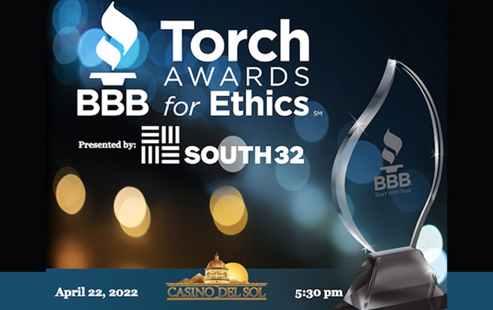
Big Brothers Big Sisters of Southern Arizona Recognized For Our Ethical Standards
We've again been named a semi-finalist for the Better Business Bureau's Torch Awards for Ethics. This honor publicly recognizes local companies and nonprofits that have practices in place that elevate their commitment to ethical business. The Torch Awards for Ethics is designed to not only promote the importance of building trust, but also the willingness and efforts made that contribute to an honorable marketplace. We'll find out if we won later in April, but it truly is an honor to be a semi-finalist, too!

